Parallel GC

Параметры запуска -XX:+UseParallelGC -Xmx12m -Xms12m -Xlog:gc:log.txt:time,level,tags

MergeSort Начало сортировки - 15:48:20.213412100

MergeSort Конец сортировки - 15:48:20.281343600

InsertSort Начало сортировки - 15:49:03.305452900

InsertSort Конец сортировки - 15:49:06.727993100

BubbleSort Начало сортировки - 15:49:51.739010100

BubbleSort Конец сортировки - 15:51:12.126057700

После запуска прошло несколько малых сборок

Добавляем 250000 объектов, размер int[] увеличивется с 405256 до 1460944, на 1055688 байт

При сортировке слиянием размер int[] увеличился до 4000000, после малой сборки упал до 3000000

Во время сортировки пузырьком размер int[] 4040920

После сортировки пузырьком размер int[] 2272920

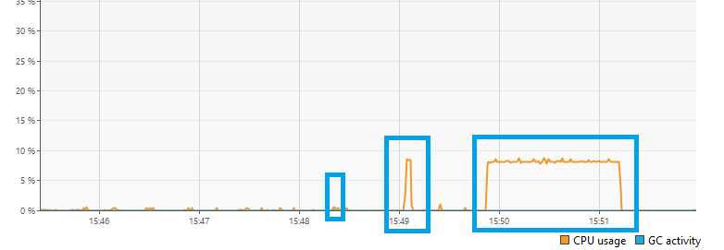

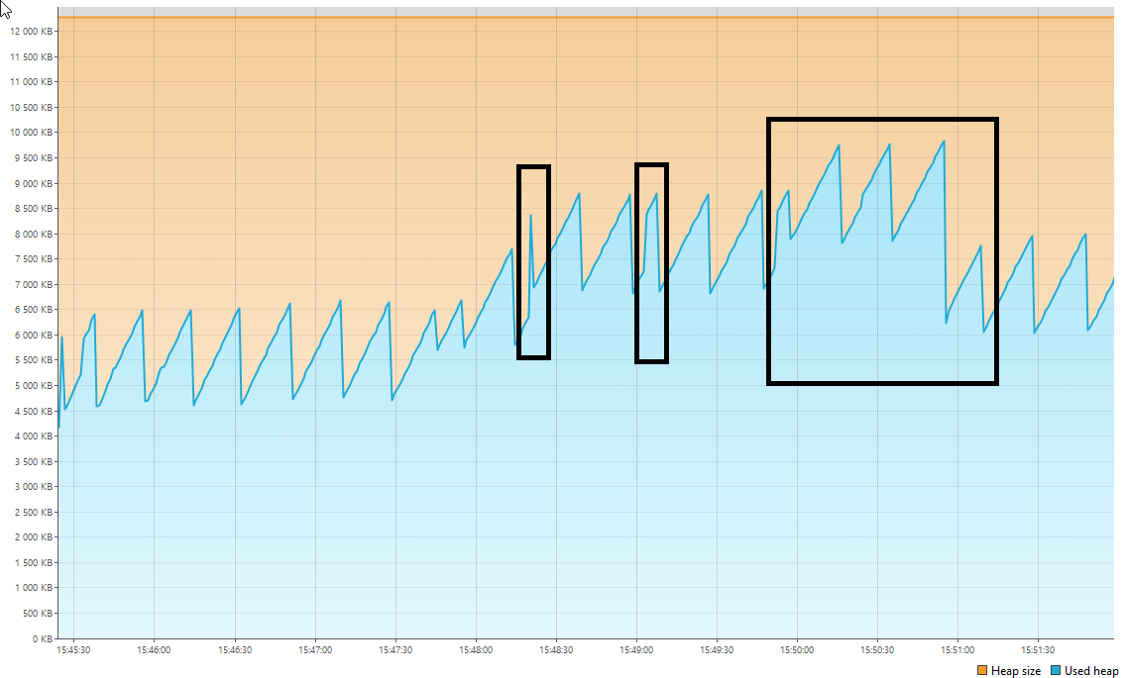

Лог:

[2024-11-02T15:45:18.141+0300][info][gc] Using Parallel

[2024-11-02T15:45:19.214+0300][info][gc] GC(0) Pause Young (Allocation Failure) 3M->1M(11M) 2.007ms

[2024-11-02T15:45:24.154+0300][info][gc] GC(1) Pause Young (Allocation Failure) 4M->2M(11M) 1.537ms

[2024-11-02T15:45:24.200+0300][info][gc] GC(2) Pause Young (Allocation Failure) 5M->3M(11M) 1.017ms

[2024-11-02T15:45:24.230+0300][info][gc] GC(3) Pause Young (Allocation Failure) 6M->4M(11M) 1.827ms

[2024-11-02T15:45:24.247+0300][info][gc] GC(4) Pause Young (Allocation Failure) 7M->5M(11M) 1.893ms

[2024-11-02T15:45:24.368+0300][info][gc] GC(5) Pause Young (Allocation Failure) 8M->6M(10M) 1.796ms

[2024-11-02T15:45:24.444+0300][info][gc] GC(6) Pause Young (Allocation Failure) 8M->6M(11M) 1.755ms

[2024-11-02T15:45:24.453+0300][info][gc] GC(7) Pause Full (Ergonomics) 6M->4M(11M) 8.617ms

[2024-11-02T15:45:26.494+0300][info][gc] GC(8) Pause Young (Allocation Failure) 6M->4M(11M) 0.704ms

[2024-11-02T15:45:38.510+0300][info][gc] GC(9) Pause Young (Allocation Failure) 6M->4M(11M) 0.603ms

[2024-11-02T15:45:56.507+0300][info][gc] GC(10) Pause Young (Allocation Failure) 6M->4M(11M) 0.903ms

[2024-11-02T15:46:14.520+0300][info][gc] GC(11) Pause Young (Allocation Failure) 6M->4M(11M) 0.475ms

[2024-11-02T15:46:32.534+0300][info][gc] GC(12) Pause Young (Allocation Failure) 6M->4M(11M) 0.372ms

[2024-11-02T15:46:50.554+0300][info][gc] GC(13) Pause Young (Allocation Failure) 6M->4M(11M) 0.367ms

[2024-11-02T15:47:09.556+0300][info][gc] GC(14) Pause Young (Allocation Failure) 6M->4M(11M) 0.324ms

[2024-11-02T15:47:27.583+0300][info][gc] GC(15) Pause Young (Allocation Failure) 6M->4M(11M) 0.352ms

[2024-11-02T15:47:44.997+0300][info][gc] GC(16) Pause Young (Allocation Failure) 6M->4M(11M) 0.356ms

[2024-11-02T15:47:54.606+0300][info][gc] GC(17) Pause Young (Allocation Failure) 6M->5M(11M) 0.396ms

[2024-11-02T15:48:13.582+0300][info][gc] GC(18) Pause Young (Allocation Failure) 7M->5M(11M) 0.372ms

[2024-11-02T15:48:20.214+0300][info][gc] GC(19) Pause Young (Allocation Failure) 7M->6M(11M) 0.324ms

[2024-11-02T15:48:20.217+0300][info][gc] GC(20) Pause Young (Allocation Failure) 8M->6M(11M) 0.258ms

[2024-11-02T15:48:20.231+0300][info][gc] GC(21) Pause Full (Ergonomics) 6M->5M(11M) 13.980ms

[2024-11-02T15:48:20.240+0300][info][gc] GC(22) Pause Young (Allocation Failure) 7M->5M(11M) 0.380ms

[2024-11-02T15:48:20.248+0300][info][gc] GC(23) Pause Young (Allocation Failure) 7M->6M(11M) 0.335ms

[2024-11-02T15:48:20.251+0300][info][gc] GC(24) Pause Young (Allocation Failure) 8M->6M(11M) 0.305ms

[2024-11-02T15:48:20.253+0300][info][gc] GC(25) Pause Young (Allocation Failure) 8M->6M(11M) 0.186ms

[2024-11-02T15:48:20.255+0300][info][gc] GC(26) Pause Young (Allocation Failure) 8M->6M(11M) 0.293ms

[2024-11-02T15:48:20.257+0300][info][gc] GC(27) Pause Young (Allocation Failure) 8M->6M(11M) 0.284ms

[2024-11-02T15:48:20.260+0300][info][gc] GC(28) Pause Young (Allocation Failure) 8M->6M(11M) 0.297ms

[2024-11-02T15:48:20.269+0300][info][gc] GC(29) Pause Full (Ergonomics) 6M->6M(11M) 9.144ms

[2024-11-02T15:48:20.271+0300][info][gc] GC(30) Pause Young (Allocation Failure) 8M->6M(11M) 0.164ms

[2024-11-02T15:48:20.273+0300][info][gc] GC(31) Pause Young (Allocation Failure) 8M->6M(11M) 0.133ms

[2024-11-02T15:48:20.274+0300][info][gc] GC(32) Pause Young (Allocation Failure) 8M->6M(11M) 0.158ms

[2024-11-02T15:48:20.277+0300][info][gc] GC(33) Pause Young (Allocation Failure) 8M->6M(11M) 0.239ms

[2024-11-02T15:48:20.279+0300][info][gc] GC(34) Pause Young (Allocation Failure) 8M->6M(11M) 0.199ms

[2024-11-02T15:48:20.641+0300][info][gc] GC(35) Pause Young (Allocation Failure) 8M->6M(11M) 0.600ms

[2024-11-02T15:48:38.646+0300][info][gc] GC(36) Pause Young (Allocation Failure) 8M->6M(11M) 0.467ms

[2024-11-02T15:48:58.601+0300][info][gc] GC(37) Pause Young (Allocation Failure) 8M->6M(11M) 0.479ms

[2024-11-02T15:49:07.671+0300][info][gc] GC(38) Pause Young (Allocation Failure) 8M->6M(11M) 0.331ms

[2024-11-02T15:49:27.619+0300][info][gc] GC(39) Pause Young (Allocation Failure) 8M->6M(11M) 0.550ms

[2024-11-02T15:49:46.702+0300][info][gc] GC(40) Pause Young (Allocation Failure) 8M->6M(11M) 1.066ms

[2024-11-02T15:49:56.705+0300][info][gc] GC(41) Pause Young (Allocation Failure) 8M->7M(11M) 0.384ms

[2024-11-02T15:50:16.634+0300][info][gc] GC(42) Pause Young (Allocation Failure) 9M->7M(11M) 0.365ms

[2024-11-02T15:50:34.729+0300][info][gc] GC(43) Pause Young (Allocation Failure) 9M->7M(11M) 0.403ms

[2024-11-02T15:50:54.745+0300][info][gc] GC(44) Pause Young (Allocation Failure) 9M->7M(11M) 0.633ms

[2024-11-02T15:50:54.754+0300][info][gc] GC(45) Pause Full (Ergonomics) 7M->5M(11M) 8.134ms

[2024-11-02T15:51:08.753+0300][info][gc] GC(46) Pause Young (Allocation Failure) 7M->5M(11M) 0.442ms

[2024-11-02T15:51:28.664+0300][info][gc] GC(47) Pause Young (Allocation Failure) 7M->5M(11M) 0.443ms

[2024-11-02T15:51:47.793+0300][info][gc] GC(48) Pause Young (Allocation Failure) 7M->5M(11M) 0.688ms

G1

Параметры запуска -XX:+UseG1GC -Xmx12m -Xms12m -Xlog:gc:log.txt:time,level,tags

MergeSort Начало сортировки - 17:26:54.810793300

MergeSort Конец сортировки - 17:26:54.878686900

InsertSort Начало сортировки - 17:27:27.634807300

InsertSort Конец сортировки - 17:27:31.134141900

BubbleSort Начало сортировки - 17:27:58.778299500

BubbleSort Конец сортировки - 17:29:19.532762400

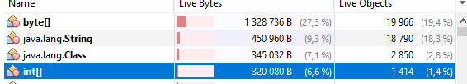







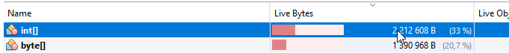

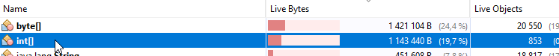

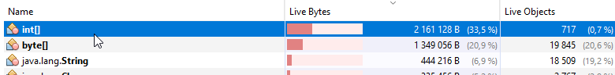

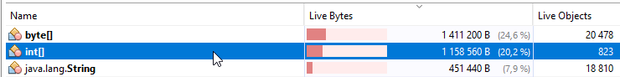

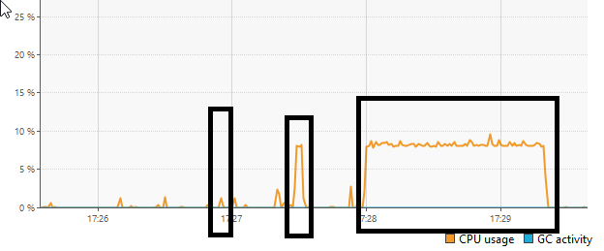

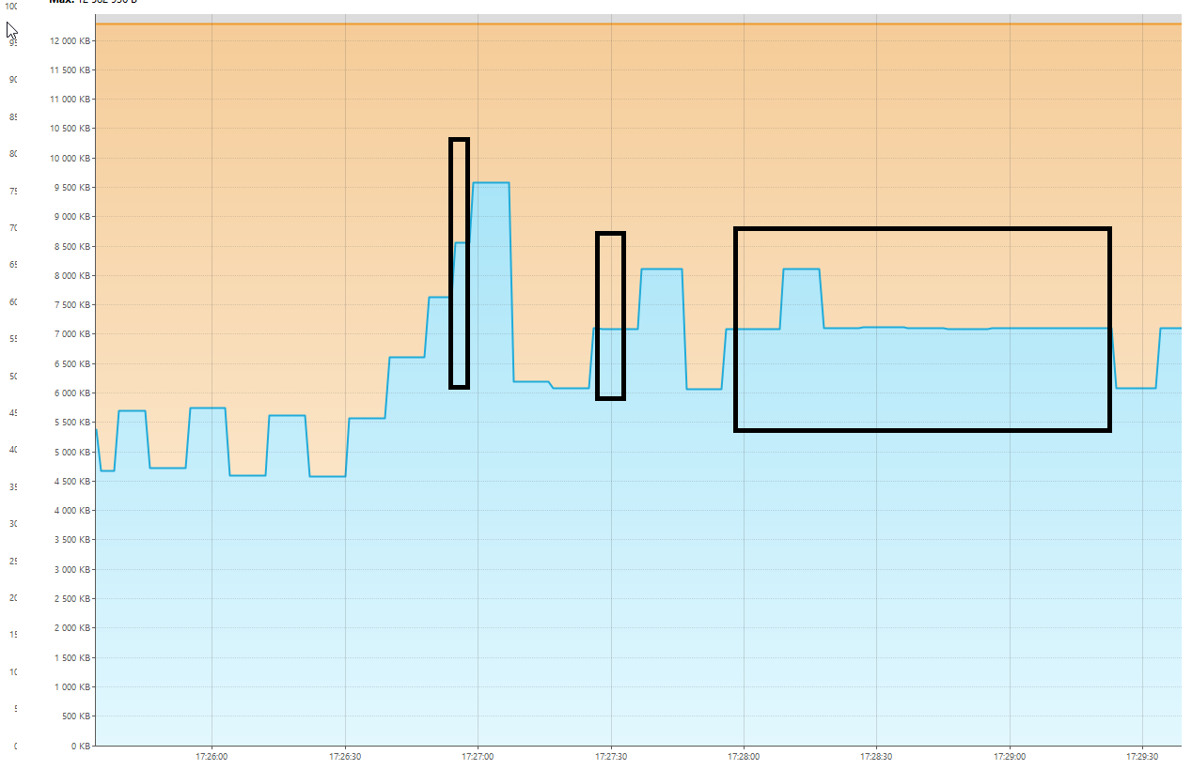

[2024-11-02T17:25:30.838+0300][info][gc] Using G1

[2024-11-02T17:25:33.442+0300][info][gc] GC(0) Pause Young (Normal) (G1 Evacuation Pause) 4M->2M(12M) 3.486ms

[2024-11-02T17:25:33.463+0300][info][gc] GC(1) Pause Young (Normal) (G1 Evacuation Pause) 3M->2M(12M) 2.005ms

[2024-11-02T17:25:33.478+0300][info][gc] GC(2) Pause Young (Normal) (G1 Evacuation Pause) 3M->2M(12M) 0.857ms

[2024-11-02T17:25:33.514+0300][info][gc] GC(3) Pause Young (Normal) (G1 Evacuation Pause) 4M->2M(12M) 0.922ms

[2024-11-02T17:25:33.545+0300][info][gc] GC(4) Pause Young (Normal) (G1 Evacuation Pause) 4M->3M(12M) 1.288ms

[2024-11-02T17:25:33.560+0300][info][gc] GC(5) Pause Young (Normal) (G1 Evacuation Pause) 5M->3M(12M) 1.513ms

[2024-11-02T17:25:33.573+0300][info][gc] GC(6) Pause Young (Normal) (G1 Evacuation Pause) 5M->3M(12M) 0.816ms

[2024-11-02T17:25:33.724+0300][info][gc] GC(7) Pause Young (Normal) (G1 Evacuation Pause) 5M->3M(12M) 0.789ms

[2024-11-02T17:25:33.788+0300][info][gc] GC(8) Pause Young (Normal) (G1 Evacuation Pause) 5M->3M(12M) 1.308ms

[2024-11-02T17:25:33.866+0300][info][gc] GC(9) Pause Young (Normal) (G1 Evacuation Pause) 5M->4M(12M) 1.673ms

[2024-11-02T17:25:34.920+0300][info][gc] GC(10) Pause Young (Normal) (G1 Evacuation Pause) 6M->4M(12M) 1.427ms

[2024-11-02T17:25:45.938+0300][info][gc] GC(11) Pause Young (Normal) (G1 Evacuation Pause) 6M->4M(12M) 1.389ms

[2024-11-02T17:26:03.931+0300][info][gc] GC(12) Pause Young (Normal) (G1 Evacuation Pause) 6M->4M(12M) 0.953ms

[2024-11-02T17:26:20.948+0300][info][gc] GC(13) Pause Young (Normal) (G1 Evacuation Pause) 6M->4M(12M) 1.427ms

[2024-11-02T17:26:30.850+0300][info][gc] GC(14) Pause Young (Concurrent Start) (G1 Humongous Allocation) 5M->4M(12M) 1.352ms

[2024-11-02T17:26:30.850+0300][info][gc] GC(15) Concurrent Undo Cycle

[2024-11-02T17:26:30.850+0300][info][gc] GC(15) Concurrent Undo Cycle 0.100ms

[2024-11-02T17:26:54.812+0300][info][gc] GC(16) Pause Young (Concurrent Start) (G1 Humongous Allocation) 8M->5M(12M) 1.830ms

[2024-11-02T17:26:54.812+0300][info][gc] GC(17) Concurrent Mark Cycle

[2024-11-02T17:26:54.818+0300][info][gc] GC(17) Pause Remark 7M->7M(12M) 3.036ms

[2024-11-02T17:26:54.819+0300][info][gc] GC(17) Pause Cleanup 8M->8M(12M) 0.095ms

[2024-11-02T17:26:54.819+0300][info][gc] GC(17) Concurrent Mark Cycle 7.534ms

[2024-11-02T17:26:54.823+0300][info][gc] GC(18) Pause Young (Normal) (G1 Evacuation Pause) 8M->6M(12M) 1.510ms

[2024-11-02T17:26:54.829+0300][info][gc] GC(19) Pause Young (Concurrent Start) (G1 Evacuation Pause) 7M->6M(12M) 1.393ms

[2024-11-02T17:26:54.829+0300][info][gc] GC(20) Concurrent Mark Cycle

[2024-11-02T17:26:54.833+0300][info][gc] GC(20) Pause Remark 6M->6M(12M) 1.721ms

[2024-11-02T17:26:54.834+0300][info][gc] GC(20) Pause Cleanup 7M->7M(12M) 0.110ms

[2024-11-02T17:26:54.834+0300][info][gc] GC(20) Concurrent Mark Cycle 5.217ms

[2024-11-02T17:26:54.837+0300][info][gc] GC(21) Pause Young (Normal) (G1 Evacuation Pause) 7M->6M(12M) 1.279ms

[2024-11-02T17:26:54.840+0300][info][gc] GC(22) Pause Young (Concurrent Start) (G1 Evacuation Pause) 7M->6M(12M) 1.019ms

[2024-11-02T17:26:54.840+0300][info][gc] GC(23) Concurrent Mark Cycle

[2024-11-02T17:26:54.842+0300][info][gc] GC(24) Pause Young (Normal) (G1 Evacuation Pause) 7M->6M(12M) 0.853ms

[2024-11-02T17:26:54.845+0300][info][gc] GC(23) Pause Remark 7M->7M(12M) 1.421ms

[2024-11-02T17:26:54.847+0300][info][gc] GC(25) Pause Young (Normal) (G1 Evacuation Pause) 7M->6M(12M) 0.859ms

[2024-11-02T17:26:54.847+0300][info][gc] GC(23) Pause Cleanup 6M->6M(12M) 0.044ms

[2024-11-02T17:26:54.847+0300][info][gc] GC(23) Concurrent Mark Cycle 6.779ms

[2024-11-02T17:26:54.849+0300][info][gc] GC(26) Pause Young (Normal) (G1 Evacuation Pause) 7M->6M(12M) 0.811ms

[2024-11-02T17:26:54.851+0300][info][gc] GC(27) Pause Young (Concurrent Start) (G1 Evacuation Pause) 7M->6M(12M) 0.825ms

[2024-11-02T17:26:54.851+0300][info][gc] GC(28) Concurrent Mark Cycle

[2024-11-02T17:26:54.852+0300][info][gc] GC(29) Pause Young (Normal) (G1 Evacuation Pause) 7M->6M(12M) 0.735ms

[2024-11-02T17:26:54.854+0300][info][gc] GC(30) Pause Young (Normal) (G1 Evacuation Pause) 7M->6M(12M) 0.493ms

[2024-11-02T17:26:54.855+0300][info][gc] GC(28) Pause Remark 6M->6M(12M) 1.175ms

[2024-11-02T17:26:54.856+0300][info][gc] GC(28) Pause Cleanup 7M->7M(12M) 0.030ms

[2024-11-02T17:26:54.856+0300][info][gc] GC(28) Concurrent Mark Cycle 5.470ms

[2024-11-02T17:26:54.857+0300][info][gc] GC(31) Pause Young (Normal) (G1 Evacuation Pause) 8M->6M(12M) 0.424ms

[2024-11-02T17:26:54.860+0300][info][gc] GC(32) Pause Young (Concurrent Start) (G1 Evacuation Pause) 8M->6M(12M) 0.472ms

[2024-11-02T17:26:54.860+0300][info][gc] GC(33) Concurrent Mark Cycle

[2024-11-02T17:26:54.862+0300][info][gc] GC(34) Pause Young (Normal) (G1 Evacuation Pause) 8M->7M(12M) 0.564ms

[2024-11-02T17:26:54.865+0300][info][gc] GC(33) Pause Remark 7M->7M(12M) 2.188ms

[2024-11-02T17:26:54.866+0300][info][gc] GC(33) Pause Cleanup 8M->8M(12M) 0.019ms

[2024-11-02T17:26:54.866+0300][info][gc] GC(33) Concurrent Mark Cycle 5.763ms

[2024-11-02T17:26:54.867+0300][info][gc] GC(35) Pause Young (Normal) (G1 Evacuation Pause) 9M->7M(12M) 0.285ms

[2024-11-02T17:26:54.869+0300][info][gc] GC(36) Pause Young (Concurrent Start) (G1 Evacuation Pause) 9M->7M(12M) 0.407ms

[2024-11-02T17:26:54.869+0300][info][gc] GC(37) Concurrent Mark Cycle

[2024-11-02T17:26:54.872+0300][info][gc] GC(37) Pause Remark 9M->9M(12M) 1.839ms

[2024-11-02T17:26:54.873+0300][info][gc] GC(38) Pause Young (Normal) (G1 Evacuation Pause) 9M->7M(12M) 0.331ms

[2024-11-02T17:26:54.874+0300][info][gc] GC(37) Pause Cleanup 8M->8M(12M) 0.017ms

[2024-11-02T17:26:54.874+0300][info][gc] GC(37) Concurrent Mark Cycle 4.954ms

[2024-11-02T17:26:54.875+0300][info][gc] GC(39) Pause Young (Normal) (G1 Evacuation Pause) 9M->7M(12M) 0.243ms

[2024-11-02T17:26:54.877+0300][info][gc] GC(40) Pause Young (Concurrent Start) (G1 Humongous Allocation) 8M->7M(12M) 0.275ms

[2024-11-02T17:26:54.877+0300][info][gc] GC(41) Concurrent Mark Cycle

[2024-11-02T17:26:54.880+0300][info][gc] GC(41) Pause Remark 8M->8M(12M) 1.212ms

[2024-11-02T17:26:54.881+0300][info][gc] GC(41) Pause Cleanup 8M->8M(12M) 0.018ms

[2024-11-02T17:26:54.881+0300][info][gc] GC(41) Concurrent Mark Cycle 3.936ms

[2024-11-02T17:27:06.984+0300][info][gc] GC(42) Pause Young (Normal) (G1 Preventive Collection) 10M->6M(12M) 0.910ms

[2024-11-02T17:27:15.990+0300][info][gc] GC(43) Pause Young (Concurrent Start) (G1 Evacuation Pause) 7M->5M(12M) 1.089ms

[2024-11-02T17:27:15.991+0300][info][gc] GC(44) Concurrent Mark Cycle

[2024-11-02T17:27:15.995+0300][info][gc] GC(44) Pause Remark 6M->6M(12M) 2.053ms

[2024-11-02T17:27:15.996+0300][info][gc] GC(44) Pause Cleanup 6M->6M(12M) 0.092ms

[2024-11-02T17:27:15.996+0300][info][gc] GC(44) Concurrent Mark Cycle 5.804ms

[2024-11-02T17:27:27.635+0300][info][gc] GC(45) Pause Young (Concurrent Start) (G1 Humongous Allocation) 7M->5M(12M) 1.404ms

[2024-11-02T17:27:27.635+0300][info][gc] GC(46) Concurrent Mark Cycle

[2024-11-02T17:27:27.641+0300][info][gc] GC(46) Pause Remark 6M->6M(12M) 2.705ms

[2024-11-02T17:27:27.642+0300][info][gc] GC(46) Pause Cleanup 6M->6M(12M) 0.102ms

[2024-11-02T17:27:27.642+0300][info][gc] GC(46) Concurrent Mark Cycle 7.029ms

[2024-11-02T17:27:46.007+0300][info][gc] GC(47) Pause Young (Normal) (G1 Evacuation Pause) 8M->5M(12M) 1.024ms

[2024-11-02T17:27:58.780+0300][info][gc] GC(48) Pause Young (Concurrent Start) (G1 Humongous Allocation) 7M->5M(12M) 1.160ms

[2024-11-02T17:27:58.780+0300][info][gc] GC(49) Concurrent Mark Cycle

[2024-11-02T17:27:58.786+0300][info][gc] GC(49) Pause Remark 6M->6M(12M) 2.064ms

[2024-11-02T17:27:58.787+0300][info][gc] GC(49) Pause Cleanup 6M->6M(12M) 0.112ms

[2024-11-02T17:27:58.788+0300][info][gc] GC(49) Concurrent Mark Cycle 7.764ms

[2024-11-02T17:28:17.033+0300][info][gc] GC(50) Pause Young (Normal) (G1 Evacuation Pause) 8M->6M(12M) 0.672ms

[2024-11-02T17:28:26.033+0300][info][gc] GC(51) Pause Young (Concurrent Start) (G1 Evacuation Pause) 7M->6M(12M) 1.043ms

[2024-11-02T17:28:26.033+0300][info][gc] GC(52) Concurrent Mark Cycle

[2024-11-02T17:28:26.037+0300][info][gc] GC(52) Pause Remark 6M->6M(12M) 1.762ms

[2024-11-02T17:28:26.038+0300][info][gc] GC(52) Pause Cleanup 6M->6M(12M) 0.117ms

[2024-11-02T17:28:26.038+0300][info][gc] GC(52) Concurrent Mark Cycle 5.461ms

[2024-11-02T17:28:36.037+0300][info][gc] GC(53) Pause Young (Normal) (G1 Evacuation Pause) 7M->6M(12M) 0.925ms

[2024-11-02T17:28:45.047+0300][info][gc] GC(54) Pause Young (Concurrent Start) (G1 Evacuation Pause) 7M->6M(12M) 1.107ms

[2024-11-02T17:28:45.047+0300][info][gc] GC(55) Concurrent Mark Cycle

[2024-11-02T17:28:45.051+0300][info][gc] GC(55) Pause Remark 6M->6M(12M) 1.976ms

[2024-11-02T17:28:45.052+0300][info][gc] GC(55) Pause Cleanup 6M->6M(12M) 0.102ms

[2024-11-02T17:28:45.053+0300][info][gc] GC(55) Concurrent Mark Cycle 5.502ms

[2024-11-02T17:28:55.052+0300][info][gc] GC(56) Pause Young (Normal) (G1 Evacuation Pause) 7M->6M(12M) 0.937ms

[2024-11-02T17:29:05.002+0300][info][gc] GC(57) Pause Young (Concurrent Start) (G1 Evacuation Pause) 7M->6M(12M) 1.077ms

[2024-11-02T17:29:05.002+0300][info][gc] GC(58) Concurrent Mark Cycle

[2024-11-02T17:29:05.006+0300][info][gc] GC(58) Pause Remark 6M->6M(12M) 1.726ms

[2024-11-02T17:29:05.007+0300][info][gc] GC(58) Pause Cleanup 6M->6M(12M) 0.112ms

[2024-11-02T17:29:05.008+0300][info][gc] GC(58) Concurrent Mark Cycle 5.364ms

[2024-11-02T17:29:14.065+0300][info][gc] GC(59) Pause Young (Normal) (G1 Evacuation Pause) 7M->6M(12M) 1.087ms

[2024-11-02T17:29:24.012+0300][info][gc] GC(60) Pause Young (Concurrent Start) (G1 Evacuation Pause) 7M->5M(12M) 1.096ms

[2024-11-02T17:29:24.012+0300][info][gc] GC(61) Concurrent Mark Cycle

[2024-11-02T17:29:24.015+0300][info][gc] GC(61) Pause Remark 5M->5M(12M) 1.651ms

[2024-11-02T17:29:24.016+0300][info][gc] GC(61) Pause Cleanup 5M->5M(12M) 0.108ms

[2024-11-02T17:29:24.016+0300][info][gc] GC(61) Concurrent Mark Cycle 4.832ms

ZGC

Параметры запуска -XX:+UseZGC –Xmx20m –Xms20m -Xlog:gc:log.txt:time,level,tags

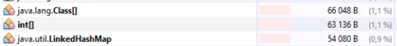

Добавляем 250000 объектов, размер int[] увеличивется с 63136 до 1062912



После сортировки вставкой



Сортировка слиянием - 

Затем опять уменьшился



Сортировка пузырьком так же, как и слиянием, с 1062896 до 2062912 и обратно

MergeSort Начало сортировки - 17:46:28.454251900

MergeSort Конец сортировки - 17:46:28.537975

InsertSort Начало сортировки - 17:46:49.927064200

InsertSort Конец сортировки - 17:46:53.478362700

BubbleSort Начало сортировки - 17:47:04.831220300

BubbleSort Конец сортировки - 17:48:23.992348200

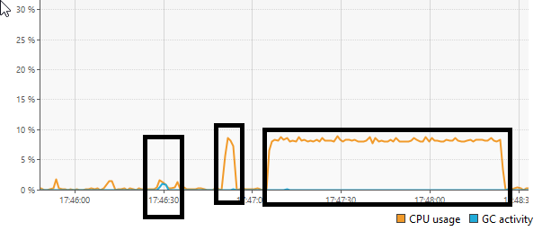

При использовании ZGC заметно использование CPU для сборщика мусора

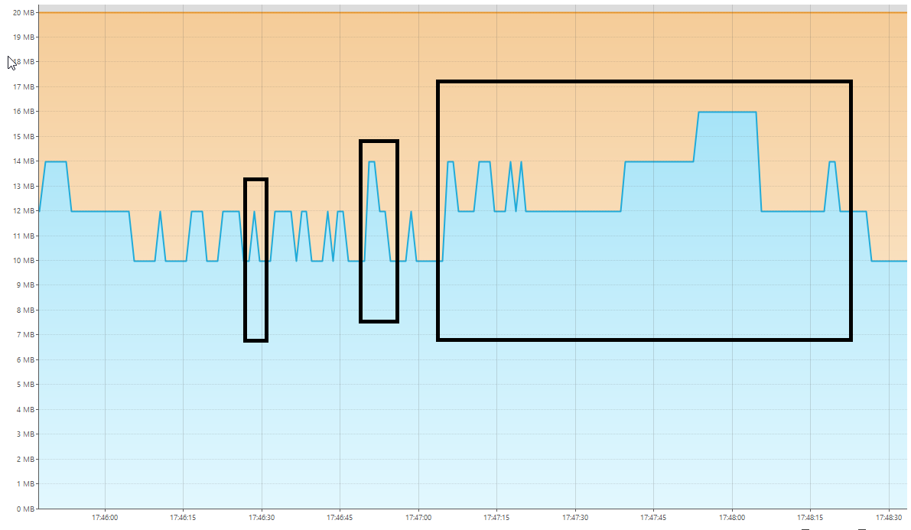

[2024-11-02T17:45:40.620+0300][info][gc] Using The Z Garbage Collector

[2024-11-02T17:45:40.761+0300][info][gc] GC(0) Garbage Collection (Warmup) 4M(20%)->4M(20%)

[2024-11-02T17:45:40.853+0300][info][gc] GC(1) Garbage Collection (Warmup) 4M(20%)->4M(20%)

[2024-11-02T17:45:41.760+0300][info][gc] GC(2) Garbage Collection (Warmup) 6M(30%)->4M(20%)

[2024-11-02T17:45:46.459+0300][info][gc] GC(3) Garbage Collection (Proactive) 10M(50%)->6M(30%)

[2024-11-02T17:45:46.555+0300][info][gc] GC(4) Garbage Collection (Allocation Rate) 16M(80%)->8M(40%)

[2024-11-02T17:45:46.662+0300][info][gc] GC(5) Garbage Collection (Allocation Rate) 8M(40%)->6M(30%)

[2024-11-02T17:45:46.756+0300][info][gc] GC(6) Garbage Collection (Allocation Rate) 8M(40%)->6M(30%)

[2024-11-02T17:45:46.858+0300][info][gc] GC(7) Garbage Collection (Allocation Rate) 8M(40%)->8M(40%)

[2024-11-02T17:45:46.960+0300][info][gc] GC(8) Garbage Collection (Allocation Rate) 8M(40%)->6M(30%)

[2024-11-02T17:45:47.048+0300][info][gc] GC(9) Garbage Collection (Allocation Rate) 8M(40%)->6M(30%)

[2024-11-02T17:45:47.161+0300][info][gc] GC(10) Garbage Collection (Allocation Rate) 8M(40%)->6M(30%)

[2024-11-02T17:45:47.255+0300][info][gc] GC(11) Garbage Collection (Allocation Rate) 8M(40%)->8M(40%)

[2024-11-02T17:45:47.354+0300][info][gc] GC(12) Garbage Collection (Allocation Rate) 10M(50%)->8M(40%)

[2024-11-02T17:45:47.561+0300][info][gc] GC(13) Garbage Collection (Allocation Rate) 12M(60%)->10M(50%)

[2024-11-02T17:45:52.655+0300][info][gc] GC(14) Garbage Collection (Proactive) 12M(60%)->8M(40%)

[2024-11-02T17:45:53.769+0300][info][gc] GC(15) Garbage Collection (Proactive) 10M(50%)->10M(50%)

[2024-11-02T17:46:03.664+0300][info][gc] GC(16) Garbage Collection (Proactive) 12M(60%)->8M(40%)

[2024-11-02T17:46:04.956+0300][info][gc] GC(17) Garbage Collection (Proactive) 10M(50%)->8M(40%)

[2024-11-02T17:46:06.163+0300][info][gc] GC(18) Garbage Collection (Proactive) 10M(50%)->8M(40%)

[2024-11-02T17:46:07.161+0300][info][gc] GC(19) Garbage Collection (Proactive) 10M(50%)->8M(40%)

[2024-11-02T17:46:08.669+0300][info][gc] GC(20) Garbage Collection (Proactive) 10M(50%)->8M(40%)

[2024-11-02T17:46:10.062+0300][info][gc] GC(21) Garbage Collection (Proactive) 12M(60%)->10M(50%)

[2024-11-02T17:46:11.461+0300][info][gc] GC(22) Garbage Collection (Proactive) 12M(60%)->10M(50%)

[2024-11-02T17:46:12.455+0300][info][gc] GC(23) Garbage Collection (Proactive) 12M(60%)->10M(50%)

[2024-11-02T17:46:13.565+0300][info][gc] GC(24) Garbage Collection (Proactive) 12M(60%)->10M(50%)

[2024-11-02T17:46:14.959+0300][info][gc] GC(25) Garbage Collection (Proactive) 12M(60%)->10M(50%)

[2024-11-02T17:46:16.162+0300][info][gc] GC(26) Garbage Collection (Proactive) 12M(60%)->10M(50%)

[2024-11-02T17:46:17.254+0300][info][gc] GC(27) Garbage Collection (Proactive) 12M(60%)->10M(50%)

[2024-11-02T17:46:18.263+0300][info][gc] GC(28) Garbage Collection (Proactive) 12M(60%)->10M(50%)

[2024-11-02T17:46:19.155+0300][info][gc] GC(29) Garbage Collection (Proactive) 12M(60%)->10M(50%)

[2024-11-02T17:46:20.057+0300][info][gc] GC(30) Garbage Collection (Proactive) 12M(60%)->10M(50%)

[2024-11-02T17:46:21.051+0300][info][gc] GC(31) Garbage Collection (Proactive) 12M(60%)->10M(50%)

[2024-11-02T17:46:21.863+0300][info][gc] GC(32) Garbage Collection (Proactive) 12M(60%)->10M(50%)

[2024-11-02T17:46:22.661+0300][info][gc] GC(33) Garbage Collection (Proactive) 12M(60%)->10M(50%)

[2024-11-02T17:46:23.659+0300][info][gc] GC(34) Garbage Collection (Proactive) 12M(60%)->10M(50%)

[2024-11-02T17:46:24.660+0300][info][gc] GC(35) Garbage Collection (Proactive) 12M(60%)->10M(50%)

[2024-11-02T17:46:25.657+0300][info][gc] GC(36) Garbage Collection (Proactive) 12M(60%)->10M(50%)

[2024-11-02T17:46:26.654+0300][info][gc] GC(37) Garbage Collection (Proactive) 12M(60%)->10M(50%)

[2024-11-02T17:46:27.661+0300][info][gc] GC(38) Garbage Collection (Proactive) 12M(60%)->10M(50%)

[2024-11-02T17:46:28.489+0300][info][gc] Allocation Stall (main) 10.626ms

[2024-11-02T17:46:28.489+0300][info][gc] GC(39) Garbage Collection (Allocation Stall) 20M(100%)->14M(70%)

[2024-11-02T17:46:28.505+0300][info][gc] Allocation Stall (main) 9.708ms

[2024-11-02T17:46:28.505+0300][info][gc] GC(40) Garbage Collection (Allocation Stall) 20M(100%)->16M(80%)

[2024-11-02T17:46:28.519+0300][info][gc] Allocation Stall (main) 9.828ms

[2024-11-02T17:46:28.520+0300][info][gc] GC(41) Garbage Collection (Allocation Stall) 20M(100%)->16M(80%)

[2024-11-02T17:46:28.535+0300][info][gc] Allocation Stall (main) 9.535ms

[2024-11-02T17:46:28.535+0300][info][gc] GC(42) Garbage Collection (Allocation Stall) 20M(100%)->18M(90%)

[2024-11-02T17:46:28.561+0300][info][gc] GC(43) Garbage Collection (Allocation Rate) 20M(100%)->8M(40%)

[2024-11-02T17:46:28.663+0300][info][gc] GC(44) Garbage Collection (Allocation Rate) 10M(50%)->10M(50%)

[2024-11-02T17:46:28.766+0300][info][gc] GC(45) Garbage Collection (Allocation Rate) 10M(50%)->10M(50%)

[2024-11-02T17:46:28.866+0300][info][gc] GC(46) Garbage Collection (Allocation Rate) 10M(50%)->10M(50%)

[2024-11-02T17:46:28.955+0300][info][gc] GC(47) Garbage Collection (Allocation Rate) 10M(50%)->10M(50%)

[2024-11-02T17:46:29.071+0300][info][gc] GC(48) Garbage Collection (Allocation Rate) 10M(50%)->10M(50%)

[2024-11-02T17:46:29.164+0300][info][gc] GC(49) Garbage Collection (Allocation Rate) 10M(50%)->10M(50%)

[2024-11-02T17:46:29.258+0300][info][gc] GC(50) Garbage Collection (Allocation Rate) 10M(50%)->10M(50%)

[2024-11-02T17:46:29.360+0300][info][gc] GC(51) Garbage Collection (Allocation Rate) 10M(50%)->10M(50%)

[2024-11-02T17:46:29.563+0300][info][gc] GC(52) Garbage Collection (Allocation Rate) 10M(50%)->10M(50%)

[2024-11-02T17:46:29.662+0300][info][gc] GC(53) Garbage Collection (Allocation Rate) 12M(60%)->10M(50%)

[2024-11-02T17:46:29.772+0300][info][gc] GC(54) Garbage Collection (Allocation Rate) 10M(50%)->10M(50%)

[2024-11-02T17:46:29.864+0300][info][gc] GC(55) Garbage Collection (Allocation Rate) 10M(50%)->10M(50%)

[2024-11-02T17:46:29.949+0300][info][gc] GC(56) Garbage Collection (Allocation Rate) 10M(50%)->10M(50%)

[2024-11-02T17:46:30.066+0300][info][gc] GC(57) Garbage Collection (Allocation Rate) 10M(50%)->10M(50%)

[2024-11-02T17:46:30.159+0300][info][gc] GC(58) Garbage Collection (Allocation Rate) 10M(50%)->10M(50%)

[2024-11-02T17:46:30.268+0300][info][gc] GC(59) Garbage Collection (Allocation Rate) 10M(50%)->10M(50%)

[2024-11-02T17:46:30.353+0300][info][gc] GC(60) Garbage Collection (Allocation Rate) 10M(50%)->10M(50%)

[2024-11-02T17:46:31.772+0300][info][gc] GC(61) Garbage Collection (Proactive) 12M(60%)->10M(50%)

[2024-11-02T17:46:33.261+0300][info][gc] GC(62) Garbage Collection (Proactive) 12M(60%)->10M(50%)

[2024-11-02T17:46:34.569+0300][info][gc] GC(63) Garbage Collection (Proactive) 12M(60%)->10M(50%)

[2024-11-02T17:46:35.769+0300][info][gc] GC(64) Garbage Collection (Proactive) 12M(60%)->10M(50%)

[2024-11-02T17:46:37.068+0300][info][gc] GC(65) Garbage Collection (Proactive) 12M(60%)->10M(50%)

[2024-11-02T17:46:38.261+0300][info][gc] GC(66) Garbage Collection (Proactive) 12M(60%)->10M(50%)

[2024-11-02T17:46:39.468+0300][info][gc] GC(67) Garbage Collection (Proactive) 12M(60%)->10M(50%)

[2024-11-02T17:46:40.653+0300][info][gc] GC(68) Garbage Collection (Proactive) 12M(60%)->10M(50%)

[2024-11-02T17:46:41.866+0300][info][gc] GC(69) Garbage Collection (Proactive) 12M(60%)->10M(50%)

[2024-11-02T17:46:42.959+0300][info][gc] GC(70) Garbage Collection (Proactive) 12M(60%)->10M(50%)

[2024-11-02T17:46:44.056+0300][info][gc] GC(71) Garbage Collection (Proactive) 12M(60%)->10M(50%)

[2024-11-02T17:46:45.152+0300][info][gc] GC(72) Garbage Collection (Proactive) 12M(60%)->10M(50%)

[2024-11-02T17:46:46.066+0300][info][gc] GC(73) Garbage Collection (Proactive) 12M(60%)->10M(50%)

[2024-11-02T17:46:47.360+0300][info][gc] GC(74) Garbage Collection (Proactive) 12M(60%)->10M(50%)

[2024-11-02T17:46:48.466+0300][info][gc] GC(75) Garbage Collection (Proactive) 12M(60%)->10M(50%)

[2024-11-02T17:46:49.462+0300][info][gc] GC(76) Garbage Collection (Proactive) 12M(60%)->10M(50%)

[2024-11-02T17:46:50.361+0300][info][gc] GC(77) Garbage Collection (Proactive) 14M(70%)->12M(60%)

[2024-11-02T17:46:51.152+0300][info][gc] GC(78) Garbage Collection (Proactive) 14M(70%)->12M(60%)

[2024-11-02T17:46:51.862+0300][info][gc] GC(79) Garbage Collection (Proactive) 14M(70%)->12M(60%)

[2024-11-02T17:46:52.650+0300][info][gc] GC(80) Garbage Collection (Proactive) 14M(70%)->12M(60%)

[2024-11-02T17:46:53.560+0300][info][gc] GC(81) Garbage Collection (Proactive) 14M(70%)->10M(50%)

[2024-11-02T17:46:54.552+0300][info][gc] GC(82) Garbage Collection (Proactive) 12M(60%)->10M(50%)

[2024-11-02T17:46:55.458+0300][info][gc] GC(83) Garbage Collection (Proactive) 12M(60%)->10M(50%)

[2024-11-02T17:46:56.253+0300][info][gc] GC(84) Garbage Collection (Proactive) 12M(60%)->10M(50%)

[2024-11-02T17:46:56.955+0300][info][gc] GC(85) Garbage Collection (Proactive) 12M(60%)->10M(50%)

[2024-11-02T17:46:57.760+0300][info][gc] GC(86) Garbage Collection (Proactive) 12M(60%)->10M(50%)

[2024-11-02T17:46:58.662+0300][info][gc] GC(87) Garbage Collection (Proactive) 12M(60%)->10M(50%)

[2024-11-02T17:47:00.051+0300][info][gc] GC(88) Garbage Collection (Proactive) 12M(60%)->10M(50%)

[2024-11-02T17:47:01.270+0300][info][gc] GC(89) Garbage Collection (Proactive) 12M(60%)->10M(50%)

[2024-11-02T17:47:02.472+0300][info][gc] GC(90) Garbage Collection (Proactive) 12M(60%)->10M(50%)

[2024-11-02T17:47:03.658+0300][info][gc] GC(91) Garbage Collection (Proactive) 12M(60%)->10M(50%)

[2024-11-02T17:47:04.862+0300][info][gc] GC(92) Garbage Collection (Proactive) 14M(70%)->12M(60%)

[2024-11-02T17:47:05.756+0300][info][gc] GC(93) Garbage Collection (Proactive) 14M(70%)->12M(60%)

[2024-11-02T17:47:06.659+0300][info][gc] GC(94) Garbage Collection (Proactive) 14M(70%)->12M(60%)

[2024-11-02T17:47:07.653+0300][info][gc] GC(95) Garbage Collection (Proactive) 14M(70%)->12M(60%)

[2024-11-02T17:47:08.660+0300][info][gc] GC(96) Garbage Collection (Proactive) 14M(70%)->12M(60%)

[2024-11-02T17:47:09.658+0300][info][gc] GC(97) Garbage Collection (Proactive) 14M(70%)->12M(60%)

[2024-11-02T17:47:10.656+0300][info][gc] GC(98) Garbage Collection (Proactive) 14M(70%)->12M(60%)

[2024-11-02T17:47:11.364+0300][info][gc] GC(99) Garbage Collection (Proactive) 14M(70%)->12M(60%)

[2024-11-02T17:47:12.758+0300][info][gc] GC(100) Garbage Collection (Proactive) 14M(70%)->12M(60%)

[2024-11-02T17:47:13.953+0300][info][gc] GC(101) Garbage Collection (Proactive) 14M(70%)->12M(60%)

[2024-11-02T17:47:14.863+0300][info][gc] GC(102) Garbage Collection (Proactive) 14M(70%)->12M(60%)

[2024-11-02T17:47:15.651+0300][info][gc] GC(103) Garbage Collection (Proactive) 14M(70%)->12M(60%)

[2024-11-02T17:47:16.653+0300][info][gc] GC(104) Garbage Collection (Proactive) 14M(70%)->12M(60%)

[2024-11-02T17:47:17.560+0300][info][gc] GC(105) Garbage Collection (Proactive) 14M(70%)->12M(60%)

[2024-11-02T17:47:18.163+0300][info][gc] GC(106) Garbage Collection (Proactive) 14M(70%)->12M(60%)

[2024-11-02T17:47:18.758+0300][info][gc] GC(107) Garbage Collection (Proactive) 14M(70%)->12M(60%)

[2024-11-02T17:47:19.655+0300][info][gc] GC(108) Garbage Collection (Proactive) 14M(70%)->12M(60%)

[2024-11-02T17:47:20.661+0300][info][gc] GC(109) Garbage Collection (Proactive) 14M(70%)->12M(60%)

[2024-11-02T17:47:21.651+0300][info][gc] GC(110) Garbage Collection (Proactive) 14M(70%)->12M(60%)

[2024-11-02T17:47:22.649+0300][info][gc] GC(111) Garbage Collection (Proactive) 14M(70%)->12M(60%)

[2024-11-02T17:47:23.659+0300][info][gc] GC(112) Garbage Collection (Proactive) 14M(70%)->12M(60%)

[2024-11-02T17:47:24.657+0300][info][gc] GC(113) Garbage Collection (Proactive) 14M(70%)->12M(60%)

[2024-11-02T17:47:25.657+0300][info][gc] GC(114) Garbage Collection (Proactive) 14M(70%)->12M(60%)

[2024-11-02T17:47:26.664+0300][info][gc] GC(115) Garbage Collection (Proactive) 14M(70%)->12M(60%)

[2024-11-02T17:47:27.661+0300][info][gc] GC(116) Garbage Collection (Proactive) 14M(70%)->12M(60%)

[2024-11-02T17:47:28.655+0300][info][gc] GC(117) Garbage Collection (Proactive) 14M(70%)->12M(60%)

[2024-11-02T17:47:29.659+0300][info][gc] GC(118) Garbage Collection (Proactive) 14M(70%)->12M(60%)

[2024-11-02T17:47:30.651+0300][info][gc] GC(119) Garbage Collection (Proactive) 14M(70%)->12M(60%)

[2024-11-02T17:47:31.661+0300][info][gc] GC(120) Garbage Collection (Proactive) 14M(70%)->12M(60%)

[2024-11-02T17:47:32.658+0300][info][gc] GC(121) Garbage Collection (Proactive) 14M(70%)->12M(60%)

[2024-11-02T17:47:33.652+0300][info][gc] GC(122) Garbage Collection (Proactive) 14M(70%)->12M(60%)

[2024-11-02T17:47:34.650+0300][info][gc] GC(123) Garbage Collection (Proactive) 14M(70%)->12M(60%)

[2024-11-02T17:47:35.665+0300][info][gc] GC(124) Garbage Collection (Proactive) 14M(70%)->12M(60%)

[2024-11-02T17:47:36.656+0300][info][gc] GC(125) Garbage Collection (Proactive) 14M(70%)->12M(60%)

[2024-11-02T17:47:37.664+0300][info][gc] GC(126) Garbage Collection (Proactive) 14M(70%)->12M(60%)

[2024-11-02T17:47:38.653+0300][info][gc] GC(127) Garbage Collection (Proactive) 14M(70%)->14M(70%)

[2024-11-02T17:47:51.663+0300][info][gc] GC(128) Garbage Collection (Proactive) 16M(80%)->12M(60%)

[2024-11-02T17:47:52.658+0300][info][gc] GC(129) Garbage Collection (Proactive) 14M(70%)->14M(70%)

[2024-11-02T17:48:04.654+0300][info][gc] GC(130) Garbage Collection (Proactive) 16M(80%)->12M(60%)

[2024-11-02T17:48:05.260+0300][info][gc] GC(131) Garbage Collection (Proactive) 14M(70%)->12M(60%)

[2024-11-02T17:48:05.864+0300][info][gc] GC(132) Garbage Collection (Proactive) 14M(70%)->12M(60%)

[2024-11-02T17:48:06.652+0300][info][gc] GC(133) Garbage Collection (Proactive) 14M(70%)->12M(60%)

[2024-11-02T17:48:07.256+0300][info][gc] GC(134) Garbage Collection (Proactive) 14M(70%)->12M(60%)

[2024-11-02T17:48:07.855+0300][info][gc] GC(135) Garbage Collection (Proactive) 14M(70%)->12M(60%)

[2024-11-02T17:48:08.651+0300][info][gc] GC(136) Garbage Collection (Proactive) 14M(70%)->12M(60%)

[2024-11-02T17:48:09.263+0300][info][gc] GC(137) Garbage Collection (Proactive) 14M(70%)->12M(60%)

[2024-11-02T17:48:09.850+0300][info][gc] GC(138) Garbage Collection (Proactive) 14M(70%)->12M(60%)

[2024-11-02T17:48:10.656+0300][info][gc] GC(139) Garbage Collection (Proactive) 14M(70%)->12M(60%)

[2024-11-02T17:48:11.260+0300][info][gc] GC(140) Garbage Collection (Proactive) 14M(70%)->12M(60%)

[2024-11-02T17:48:11.853+0300][info][gc] GC(141) Garbage Collection (Proactive) 14M(70%)->12M(60%)

[2024-11-02T17:48:12.663+0300][info][gc] GC(142) Garbage Collection (Proactive) 14M(70%)->12M(60%)

[2024-11-02T17:48:13.256+0300][info][gc] GC(143) Garbage Collection (Proactive) 14M(70%)->12M(60%)

[2024-11-02T17:48:13.863+0300][info][gc] GC(144) Garbage Collection (Proactive) 14M(70%)->12M(60%)

[2024-11-02T17:48:14.652+0300][info][gc] GC(145) Garbage Collection (Proactive) 14M(70%)->12M(60%)

[2024-11-02T17:48:15.350+0300][info][gc] GC(146) Garbage Collection (Proactive) 14M(70%)->12M(60%)

[2024-11-02T17:48:15.961+0300][info][gc] GC(147) Garbage Collection (Proactive) 14M(70%)->12M(60%)

[2024-11-02T17:48:16.651+0300][info][gc] GC(148) Garbage Collection (Proactive) 14M(70%)->12M(60%)

[2024-11-02T17:48:17.252+0300][info][gc] GC(149) Garbage Collection (Proactive) 14M(70%)->12M(60%)

[2024-11-02T17:48:17.856+0300][info][gc] GC(150) Garbage Collection (Proactive) 14M(70%)->12M(60%)

[2024-11-02T17:48:18.662+0300][info][gc] GC(151) Garbage Collection (Proactive) 14M(70%)->12M(60%)

[2024-11-02T17:48:19.264+0300][info][gc] GC(152) Garbage Collection (Proactive) 14M(70%)->12M(60%)

[2024-11-02T17:48:19.865+0300][info][gc] GC(153) Garbage Collection (Proactive) 14M(70%)->12M(60%)

[2024-11-02T17:48:20.654+0300][info][gc] GC(154) Garbage Collection (Proactive) 14M(70%)->12M(60%)

[2024-11-02T17:48:21.352+0300][info][gc] GC(155) Garbage Collection (Proactive) 14M(70%)->12M(60%)

[2024-11-02T17:48:21.953+0300][info][gc] GC(156) Garbage Collection (Proactive) 14M(70%)->12M(60%)

[2024-11-02T17:48:22.658+0300][info][gc] GC(157) Garbage Collection (Proactive) 14M(70%)->12M(60%)

[2024-11-02T17:48:23.262+0300][info][gc] GC(158) Garbage Collection (Proactive) 14M(70%)->12M(60%)

[2024-11-02T17:48:23.955+0300][info][gc] GC(159) Garbage Collection (Proactive) 14M(70%)->12M(60%)

[2024-11-02T17:48:24.566+0300][info][gc] GC(160) Garbage Collection (Proactive) 14M(70%)->10M(50%)

[2024-11-02T17:48:25.652+0300][info][gc] GC(161) Garbage Collection (Proactive) 12M(60%)->10M(50%)

[2024-11-02T17:48:26.558+0300][info][gc] GC(162) Garbage Collection (Proactive) 12M(60%)->10M(50%)

[2024-11-02T17:48:27.967+0300][info][gc] GC(163) Garbage Collection (Proactive) 12M(60%)->10M(50%)

[2024-11-02T17:48:29.155+0300][info][gc] GC(164) Garbage Collection (Proactive) 12M(60%)->10M(50%)

[2024-11-02T17:48:30.360+0300][info][gc] GC(165) Garbage Collection (Proactive) 12M(60%)->10M(50%)

[2024-11-02T17:48:31.459+0300][info][gc] GC(166) Garbage Collection (Proactive) 12M(60%)->10M(50%)

[2024-11-02T17:48:32.455+0300][info][gc] GC(167) Garbage Collection (Proactive) 12M(60%)->10M(50%)

[2024-11-02T17:48:33.267+0300][info][gc] GC(168) Garbage Collection (Proactive) 12M(60%)->10M(50%)